The Math House Newsletter
Hello, this is the inaugural edition of my newsletter, The Math House, taking the name from my book. The purpose of my monthly newsletter is to provide readers with timely and current issues in education. I invite readers to suggest educational topics that interest you. Please send comments or questions to info@yourpencilbox.com. Happy reading and thank you for your support!  Online Book Club  Did you buy my Math House book for your child or grandchild? Are you interested in allowing them to participate in an online book club? The purpose of this book club is to see what children think about my book (favorite parts, thoughts, and other reactions). The club meeting will take place on Saturday, November 6th from 11:00 am - 12:00 pm via Zoom. Please email me at info@yourpencilbox.com to sign up and receive the link. Participants have a chance to win school supplies!  KIDS CORNER  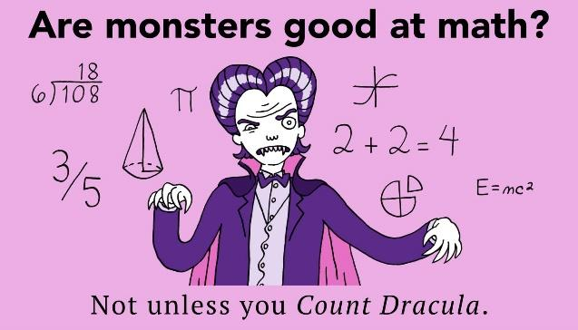  SPOOKY WORD PROBLEM  Samantha visited 132 houses while trick-or-treating. Andy trick-or-treated at 168 houses. How many more houses did Andy visit than Samantha?  Answer: 36 | Schools Grappling with “COVID SLIDE”  Children are now back in school for in–person learning, and the academic costs of the pandemic are now in the light. Low test scores reveal just how much learning was not absorbed by students as school districts around the country struggled to provide quality virtual learning for students throughout the pandemic.  School buildings across the country are now fully reopened for learning, and teachers and administrators are looking at how to get students back on track.  Many educators predicted some type of “COVID slide” mimicking the annual "summer slide" seen when students are out of the classroom, but the new results show just how bad the slide really is.  NWEA found that on MAP tests given to 3rd– 8th grade students nationwide, reading scores were between 3 to 6 percentile points lower compared to pre-pandemic levels, and median math achievement dropped 8 to 12 percentile points.  Reading achievement for Asian-American and White students dropped on average about 5 percentile points; for Black and Latino students, growth fell between 4 and 10 points.  In math the differences were more pronounced, NWEA found that there were achievement declines of up to 17 points for Black, Latino and Native-American students, almost twice that of their White and Asian-American counterparts.  Students in schools with low- poverty rates saw declines of 2 or 3 points in reading and up to 9 points in math. Students in high-poverty schools saw results that were down 4 to 11 points in reading, and 6 to 17 points in math.  References:  Kuhfeld, M., Ruzek, E., Lewis, K., McEachin, A. (2021). Technical appendix for: Learning during COVID-19: Reading and math achievement in the 2020-21 school year. NWEA.  Lewis, K., Kuhfeld, M., Ruzek, E., McEachin, A. (2021).  Learning during COVID-19: Reading and math achievement in the 2020-21 school year. NWEA

